Don’t worry about your roses. Everybody is suffering with mildew and black spot. It is because of our cold rainy spring. Cornell Univ. came up with a mildew cure https://www.vegetables.cornell.edu/pest-management/disease-factsheets/cucurbit-powdery-mildew/.
For black spot and anthracnose I use neem oil.

When you harvest your garlic, lettuce, or whatever, don’t leave that space! There is still time for planting.
Crops you can plant in June:
Beets, broccoli, cauliflower, sweet corn, cucumber, eggplant, carrots
Crops you can plant in July:
Beans (later in the month because they are cool weather lovers) beets, cauliflower, celery, okra, peas (later in the month,) turnip
Crops you can plant in August:
Collards, kale, spinach, radish, kale, collards

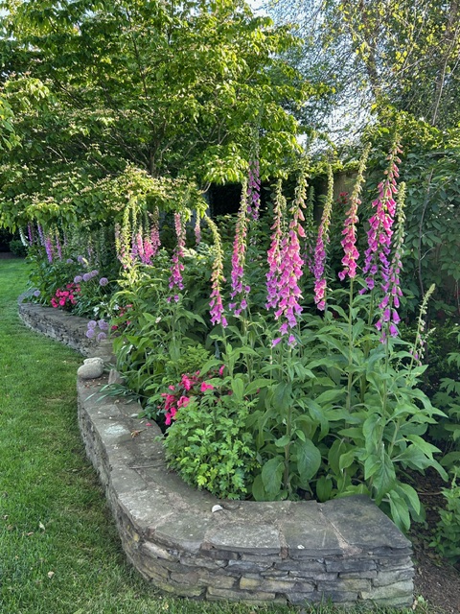

Two years ago I bought four foxglove plants. They were very pretty but almost $20 a pot. They threw seeds and sprouted and I thinned them out. Last year the new plants adorned my garden with handsome, green leaf-rosettes because digitalis (foxglove) is a biennial and you don’t get flowers the first year. Wow! This year my investment paid off, well just look at the photo!
Drastic measures during water bans are sometimes required. Many gardeners use gray water which is water from bathtub and kitchen sink. It works as long as you don’t use harsh detergents. Use a simple soap like Dr Bonner’s in the shower/tub. You can probably get more than ten gallons and with a cheap bilge pump you can easily fill up a watering can many times. At the kitchen sink rinse dishes, vegetables, etc., over a plastic basin that you can just take out into the yard and dump. It is okay to have floating vegetable matter but no hunks of meat or fish please or you’ll be inviting raccoons to come and dig. Don’t pour gray water onto plants, pour it onto the soil. Don’t use gray water with soap on super acid-loving plants because soap is alkaline.

