**June 2023 Garden Club Newsletter**

Greetings, Garden Club Members!

Pour an iced tea. This will be long.

I can officially say, “Welcome, Summer!” I must confess, it is my favorite time of year. My gardens are blooming, the house will soon be overflowing with family, “Camp Grammy” will be in session, there are wonderful books to be read, and I can go barefoot almost all of the time!

As a club, we have been very busy since my May Newsletter. Earlier this month, we took part in the British Motorcars In Bristol event. They asked us to decorate their two flagpoles; Bonnie Pacheco and Maggie Rezendes did a lovely job and received many many compliments! The roses used will be repurposed on the parade float, and then they will get planted at Mrs. Perry’s Garden. The event committee was very appreciative. We also set up our tent there: we sold some kokedamas and decoupaged shells, we took some daffodil bulb preorders, and we might have some potential new members. It was a day well spent. We also managed to put everything into our cars and head home before the skies opened…my husband wasn’t quite so fortunate. He was about halfway home in his 1953 MGTD, with the top down, when he was caught in a deluge! He was soaked through and through when he got home.

Our June meeting on the14th took place at Heritage Museum and Gardens in Sandwich. What a beautiful day for a ride to Cape Cod! We enjoyed a picnic lunch in the shade while holding our business meeting; Celeste Bernardino and Marilyn Chadwick did a magnificent job as hostesses. The table they set up was beautiful, and the treats scrumptious.



After the meeting, Robyn had arranged a very delightful and informative tour of the magnificent gardens, led by Les Lutz, the Heritage’s Director of Horticulture. If you were unable to join us, Heritage is well worth the trip “over the bridge”. Several of our members also enjoyed a ride on the carousel! The inner child is never too far from the surface.



Robyn Borges and Pam Delaney are off to a great start in their new roles planning our programs.

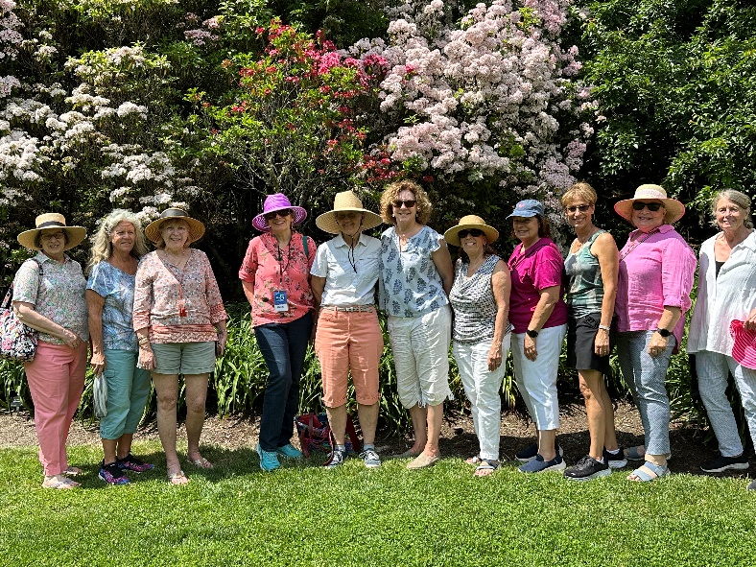

On June 21st, we partnered with Mount Hope Farm, the Portsmouth Garden Club and the Bristol Health Equity Zone for “Tick Talk”, an informational evening on how to avoid ticks and how to deal with the ticks we fail to avoid. It’s safe to say that everyone who attended will be checking themselves religiously from now on. I’m very pleased that we were part of this service to the community.

The Newport Flower Show: Laurel Curtis, Marsha Petaja and I did the club’s entry for the Garden Club Challenge. This year’s challenge was to create a container display using only white or blue flowers in a large blue and white oriental cache pot. The cache pot is supplied by the show organizers. We were assigned white flowers. It was surprisingly difficult to find pure white flowers this year. But we managed! Our vision was for a wispy, ethereal English garden and I think we succeeded. Our efforts resulted in a third place award…but our totally unbiased opinion is that ours was the loveliest. And we had fun.

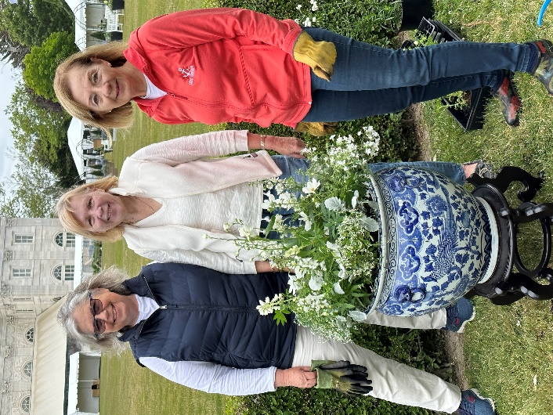

We don’t have a meeting in July, but that doesn’t mean that our club will be idle.

In a matter of days, we will have a float in the 4th of July Parade! This is the first time in a long time for us. Laurel Curtis has been working tirelessly (ok, I think she might be tired…) to find us a flat bed and truck for our float, but it looks like everything is coming together. If you’d like to participate in assembling the float, please contact Laurel. This week will be very busy!

In August, we will have a booth at the Japan-America Society of Rhode Island event. Karen Aveson and her husband, Steve, are among the organizers of this annual cultural event. Maggie Rezendes has offered to be the point person for the club, but she will need help from other members! The event takes place on August 12th, from 11:00-3:30, at Independence Park. Please reach out to Maggie if you can help.

We will also have our August meeting: a field trip for a guided tour of the Roger Williams Botanical Gardens on the 9th; Robyn Borges will be sending the details!

Thank you to everyone who has signed up to tend Mrs. Perry’s Garden and the Library Garden. Mrs. Perry’s is undergoing a transition, and I’m certain the end results will be lovely. The Library Garden is looking beautiful and while Hope Avery was weeding there the other day, many people stopped to say how much they are enjoying it!

I have an exciting new venture to put forward! We have many talented cooks within our group; our hosts seem to outdo one another each month. So, let’s get those recipes organized and put together a cookbook! Here’s how you can help: type up any recipes you have used in the past when it was your turn to host! That would extend to board members for board meeting refreshments, and for holiday luncheon potlucks. If possible, a photo would be a huge bonus.

Going forward, when you host be sure to make a copy of the recipe and whip out your phone and take a picture!

If you would like to be part of the cookbook committee, please reach out to me. Recipes should be sent to me for the time being. (Celeste, and Marilyn, those savory tarts and the angel-food cupcakes with the amazing frosting…….)

We are very sad to be saying farewell to two dear members who are moving to be nearer to their families. Barbara Blossom and Pam Bishop have both contributed so much to the Garden Club, and they will truly be missed.

One last thing, I promise! My gardens in Chatham are showing a lot of promise. I’m extending an open invitation to all of you to drop by and see them. If I am not home, feel free to wander the property! Just send me a text and I’ll give you the address and directions. Have a wonderful summer…and wear sunscreen and check for ticks!

Gail